CS 4485 Team 1 - Weekly Report
Friday, 02/20/2026
─
Jonathan Gruber (Leader) - Architectural Diagram
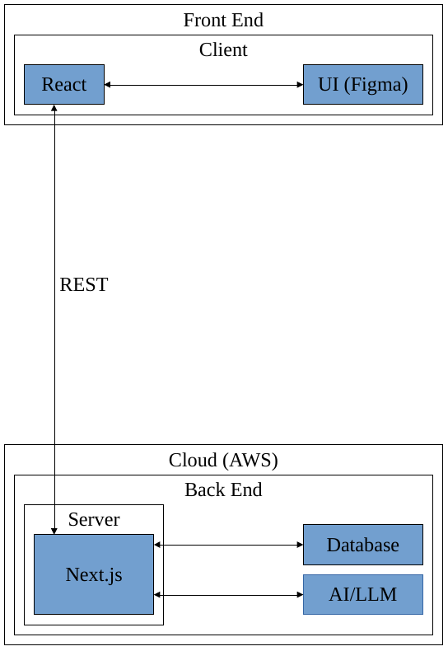

Notes

Casandra Marquez - API Contract



Notes
Next.js is a better choice for this project because it lets us build the React UI and the backend API in a single application, which simplifies development, deployment, and demoing for a one page dashboard. We can still safely call OpenAI on the server, validate and normalize the AI output into a fixed schema, and return only clean, predictable data to the UI without exposing raw AI responses. We can still enforce strict DTO based validation using schema libraries.

Sophia Chau - Figma Dashboard
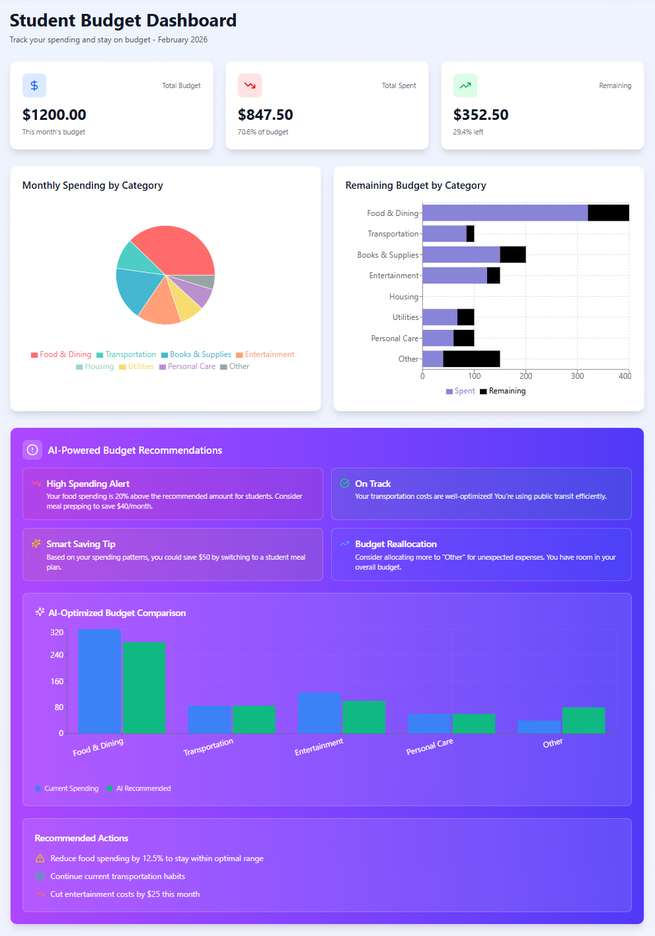

Notes

Marcelo Mejia - Mock Data

Kaggle Set 1 - 4-Year Personal Finance Dataset

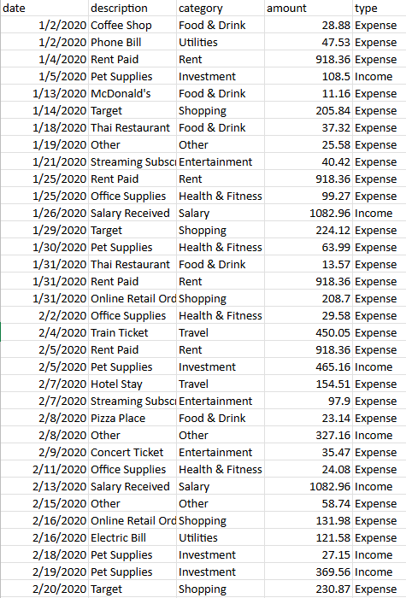

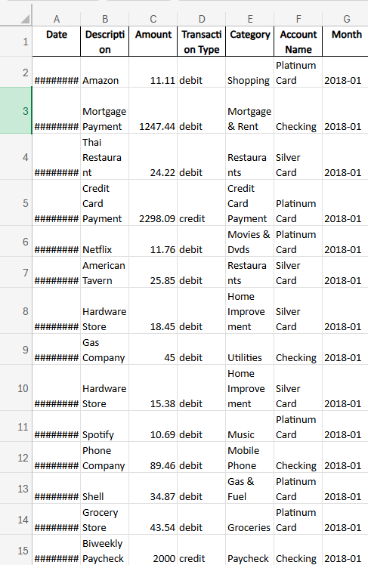
Kaggle Set 2 - Personal Transactions Dataset

Notes

Cleaned 4-Year Personal Finance Dataset - AI/Analytics Layer
- This will most likely be the primary dataset for training an AI budgeting tool in budgeting analytics and recommendations.
- It has a long time horizon which will be useful for modeling trends
- Has both income and expenses
Preprocessing/Edits:
- All transactions labeled as “Salary” were corrected to be treated as Income.
- Salary amounts were changed to be consistent month-to-month, with small periodic increases to represent raises or promotions.
- Rent amounts werechanged to be consistent month-to-month, with small annual adjustments to represent lease changes.
- The “Other” category was changed to have a mix of Income and Expense transactions.
  - Amounts in this category were rescaled so that “Other” would not disproportionately dominate total spending or income.

- The dataset originally came with gibberish in the transaction descriptions. This was replaced with realistic, category-appropriate descriptions (e.g., food, utilities, shopping, transportation).
- Salary and rent descriptions were changed to consistent labels (e.g., “Salary Received,” “Rent Paid”).
- “Other” transactions were labeled generically (“Other”).

Personal Transactions Dataset - Frontend/UI Demonstrations
- This dataset could be primarily used to seed the application UI with realistic transaction histories for demos and user interface development.
- It supports testing of features such as transaction lists, category breakdowns, and dashboard visualizations.

Jonathan Strong - AI Tool Research


Notes
Cursor vs Claude
- Cursor:
  - Free tier includes code ai
  - Utilizes multiple models including claude
  - IDE with ai built in
- Claude:
  - Autonomous coding and debugging
  - Can handle git operations
  - Multi-file understanding
- References
  - https://medium.com/@aadityaubhat/claude-code-review-ed117fa662f2
  - https://www.builder.io/blog/cursor-vs-claude-code
- AI/ML: Cursor
  - Has a free tier that include code ai while claude doesnt
  - Utilizes an older version of claude
  - VS code like IDE makes it familiar and easy to use
  - https://cursor.com/students

